2022 Lorne Sculpture Biennale and Sculpture Plus Accessibility Plan
Table of Contents
Physical Accessibility 1
Sculpture Trail 2
Aerial images of these sites are below: 3
Map from GORA detailing accessibility information and features: 6
Venue Accessibility 7
SculptureSCAPE 7
Events and Ticketing 8
Tickets and booking 8
Events 8
Spirit of Place Conversations 8
Outdoor Events 8
Free and non-ticketed 8
Staff and Volunteers 11
Information Hubs 11
Site Map 12

Physical Accessibility

As part of our work to ensure the 2022 Lorne Sculpture Biennale program is accessible and inclusive, the following steps are in place for physical accessibility:

- All indoor workshops, events and performances will be wheelchair accessible. Where a venue does not have wheelchair access, portable ramps have been hired.
- Hand rails and stairs at all venues will be checked for stability and lighting.
- The Small Sculpture exhibition will be installed with accessibility in mind with large, clear fonts displaying artist information and adequate space for people using mobility aides.
- Reserved seating at events for people with accessibility needs and support person/s.
- Entrances and exits to venues will be well-lit.
- For outdoors events, accessible matting for muddy and slippery surfaces will be in place.
- Accessible parking locations and where not possible, provision of drop-off zones.

Sculpture Trail

Please note the following precincts have limited physical access:

Tramway – Geoffrey Ricardo
Campfires – Karen Casey
The Golden Mile – Robert Hague
The Ocean Road – Ryan Kennedy
First People – Maree Clarke
The Point – Simon Buttonshaw

Aerial images of these sites:

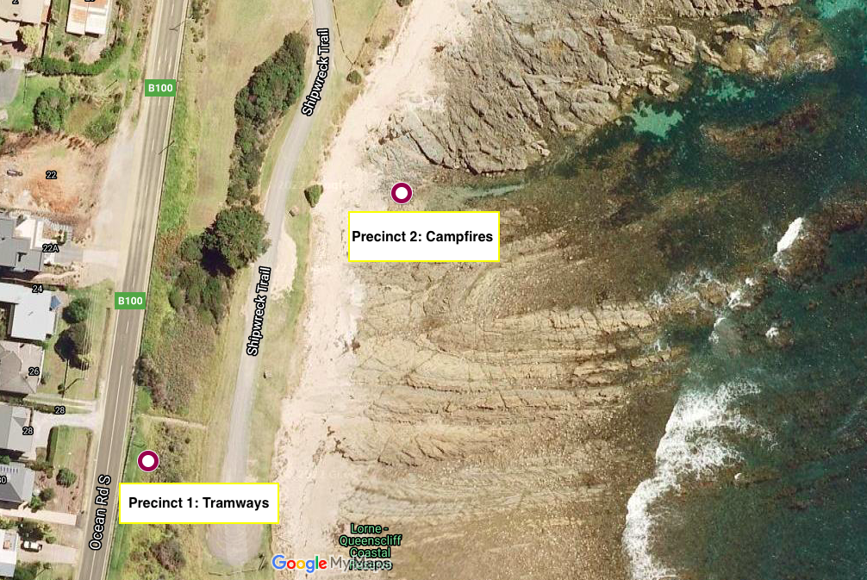

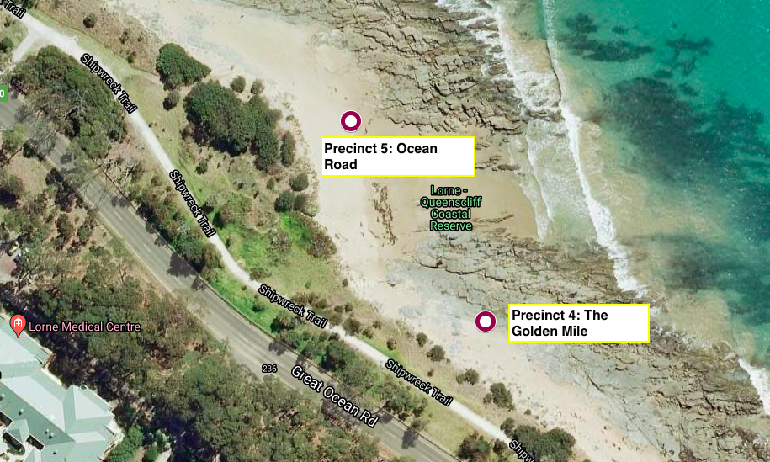

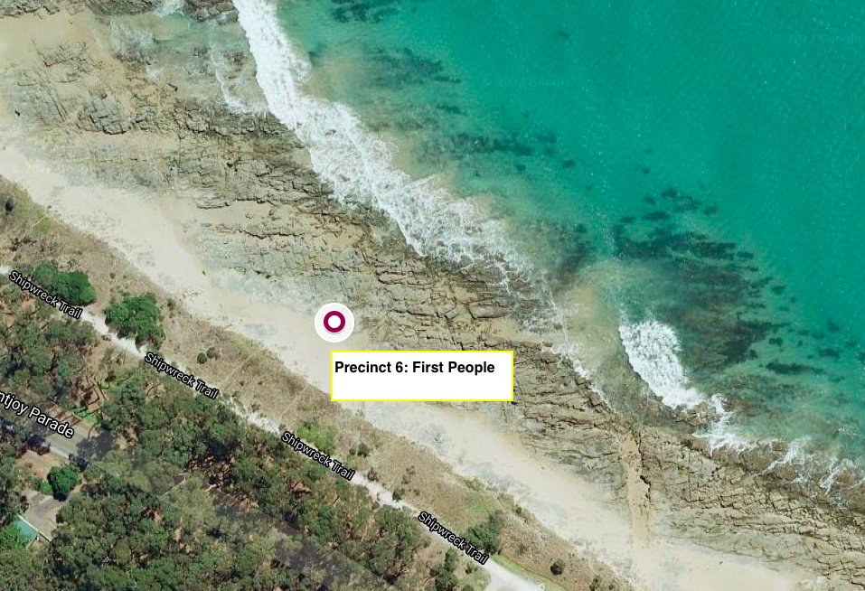

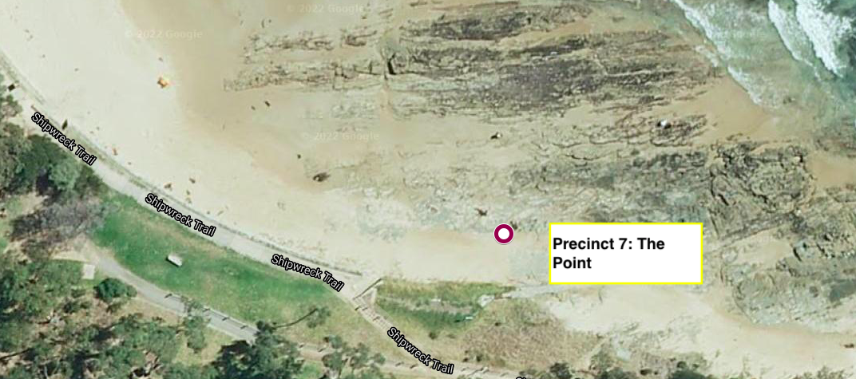

Limited access and viewing is available on the Shipwreck Trail walking path, maintained by the Great Ocean Road Authority (GORA). This path is maintained to accessibility standards. The Sculpture Trail via the Shipwreck Trail is approximately 2.3km long.

Standard manual wheelchairs are available to hire free of charge and can be collected for for short period use (i.e. less than 2 hours) from our central Information Hub on the Flat or from the Biennale Hub at the Community Connect Building in Otway Street (Small Sculpture exhibition).

Contact manager@lornesculpture at least 24 hours in advance to make a booking for longer periods of use (i.e. in excess of 2 hours).

The Great Ocean Road Authority has 1 x free beach wheelchair (for sand traverse) and hoist available for hire in Lorne. The Lorne main beach has beach access matting from January – April.

Bookings for the beach wheelchair and hoist must be made at least 2 days in advance to ensure availability.

To book contact info@greatoceanroadauthority.vic.gov.au.

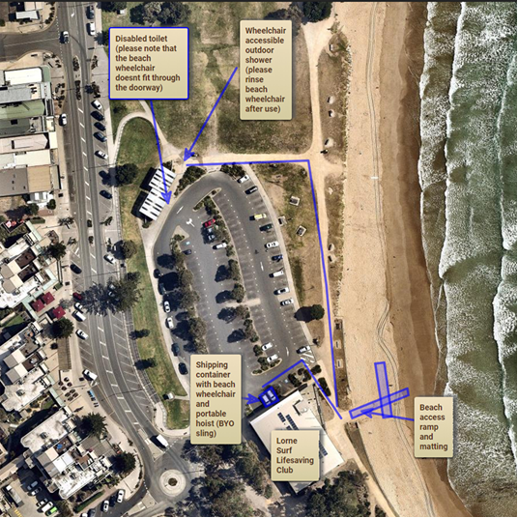
Map from GORA detailing accessibility information and features:

Venue Accessibility

When registering for our ticketed events using Eventbrite, there is the option to describe any access requirements you have. We’ll be in touch to discuss your requirements upon receiving your booking information.

Please see below for information regarding each indoor venue:

- Uniting Church Hall
The Uniting Church Hall is best accessed via Smith Street with parking available. Ramp wheelchair access is available. There are no accessible toilets available on site, however the toilets at the CFA will be made available upon booking. Please ensure this is included as part of your booking at least 5 days in advance.
- Lorne Bowls Club
The Lorne Bowls Club is an accessible building with wheelchair access and accessible toilets.
- Lorne Community Connect
Lorne Community Connect has wheelchair access and accessible toilets.
- Qdos
Indoor events running at Qdos will have wheelchair access and accessible toilets available. For outdoors workshops run on the grounds of Qdos, please indicate any requirements upon booking to ensure access needs will be met in advance.

SculptureSCAPE

SculptureSCAPE will feature temporary or ephemeral artwork by 8 artists over two weekends (19-20 March and 26-27 March).

The artworks will be displayed around the Erskine Rivermouth on the foreshore area and along the banks of the Erskine River.

Access to these sites is not possible without the use of a beach wheelchair. Surfaces are sandy.

Events and Ticketing

Tickets and booking

We accept the companion card and offer discounted ticket prices for support person/s. Please contact manager@lornesculpture.com to book using these options.

When booking events using Eventbrite, please indicate any accessibility requirements you have. We will be in touch to discuss these with you.

We offer alternative methods of booking. To book via email or phone, please contact Stacie Bobele: 0404 025 158, manager@lornesculpture.com

Events

Spirit of Place Conversations
Please note we are able hire AUSLAN interpretation for our series of Spirit of Place Conversations. If you require this, please indicate at least 5 days in advance to ensure availability.

Outdoor Events
We have many free events throughout the 2022 Lorne Sculpture Biennale. These sites and events will be manned by staff and volunteers and reserved seating is available for those with access requirements.

For more information on each of the following events please visit www.lornesculpture.com. If you have any questions regarding access for these events, please contact manager@lornesculpture.com.

Free and non-ticketed
The following events are free and non-ticketed:

- Na Djinang: Common Dissonance.
Saturday 26th March, 6-7pm.
- WildHoney: Genus Loci.
Sunday 13th March, 7.30 – 9pm.
- Darren McGinn: Talisman.
Saturday 19th March, 3-8pm.
- Pattie Beerens: Dwell.
Artist on site daily from 18th March – 2nd April, 10am – 2pm.

- Pattie Beerens – Dwell Kids Nature Experiences with Prue Gell
Saturday 19th March, 10 – 10.45am (for 2-6 year olds)
Saturday 19th March, 11am – 12pm (for 5-9 year olds)
Saturday 26th March, 10 – 10.45am (for 2-6 year olds)
Saturday 26th March, 11am - 12pm (for 5 – 9 year olds)

- Pattie Beerens: Dwell Dance Performance with Thaedra Frangos
Sunday 27th March, 12.30pm.

- Lucy O’Grady Beach Performance.
Saturday 19th March, 11am – 12pm and 4 – 5pm.

- Deborah Halpern Precinct events.

- Spectrum & the Hugh McSpedden Experience
Sunday 13th March, 8.30-10pm.
Saturday 26th March, 8.30-10pm.
- Lorne Lode: Sampling the Core. A musical performance by Michael Wallace.
Saturday 12th March, 4-5pm
Sunday 13th March, 4-5pm

- Stevens Vaughn: The Throne of Potentiality Spoken Word Event
Saturday 12th March, 4-5pm.

- Angela Barnett – Fragments Projection
Saturday 12th March
Sunday 13th March
Monday 14th March
Friday 18th March
Saturday 19th March
Sunday 20th March
Friday 25th March
Saturday 26th March
Sunday 27th March
Saturday 2nd April
Sunday 3rd April
From 7pm onwards.

- ProjectionTeknik: Projections at Lorne Cinema and Lorne Surf Lifesaving Club
Saturday 12th March
Sunday 13th March
Monday 14th March
Friday 18th March
Saturday 19th March
Sunday 20th March
Friday 25th March
Saturday 26th March
Sunday 27th March
Saturday 2nd April
Sunday 3rd April
From 7pm onwards

- Ryan F Kennedy: Ocean Road Precinct events
What it Was: Saturday 12th March, 9-10pm
What it Is: Friday 18th March, all day.
What it Could Be: Saturday 2nd April, 8-9pm

- Domenico de Clario: Flowers for Lorne
Flowers for Lorne 1: Saturday, 12 March 2022 - 7-8pm
Flowers for Lorne 2: Sunday, 13 March 2022 - 7-8pm
Flowers for Lorne 3: Saturday, 02 April 2022 - 7-8pm

The following events are free, but bookings are required:

- Themed History Discussions: So, you think you know Lorne?
Sunday 13th March, 1-2pm
Monday 14th March, 12 – 1pm
Sunday 20th March, 1-2pm
Sunday 27th March, 1-2pm

- Walk of the Sculpture Trail with Artists and Curator
Saturday 12th March, 3-4pm
- Guided History Tours
Saturday 19th March, 1-2pm
Saturday 26th March, 1-2pm

- Meet the Artist: Carmel Wallace
Sunday 27th March, 12-1pm

- Meet the Artist: Deborah Halpern
Monday 14th March, 1 – 2pm.

- Meet the Artist: Simon Normand
Saturday 2 April, 12-1pm
- Meet the Artist: Robert Hague
Sunday 20 March, 11-12pm
- Meet the Artist: Clayton Blake
Saturday 12th March, 3-4pm

- Meet the Artist: Geoffrey Ricardo
Saturday 26th March, 12- 1pm

- Meet the Artist: Simon Buttonshaw and Philomena Manifold
Saturday 19 March, 12-1pm,

Staff and Volunteers

Our team of staff and volunteers will be trained to ensure they are confident in delivering an inclusive and accessible Lorne Sculpture Biennale. If at any time throughout the event you require assistance, our team will be on hand. Our volunteers will be wearing blue Lorne Sculpture Biennale vests.

Information Hubs

Information Hubs are located at the following locations:

- Swing Bridge. Access via Otway Street.
- Lorne Aquatic Club.
- The Flat Precinct.

Site Map
